Town of Somerville
Meeting minutes for February 15, 2022
Date of this meeting March 15, 2022

- Meeting called to order by David Willis at 5:30 p.m. In attendance were David, Austin, Ruth, Trudy Willis, Elsie Willis, Azel Willis, Jessie Willis, Cliff Harris, Kix Freudenberg, Jason Stiles, Kay Hartley, Steve Bottoms, and Katelyne Diehl on Lincoln Street.
- Minutes were read and approved. Financials were read and approved.
- Old business:
- Jan. 25 David received a call from Renee Black re Azel Willis’ property and the scrap. She asked that the Town work with Azel to give him time to correct the problems. She also suggested we might want to adopt an ordinance against dumping within the Town limits. David believes we need to take under consideration. Azel stated that he is in the process of cleaning up his property.
- Katelyne stated that she appreciates what the Town has done to improve the streets. She is concerned about appreciation values. She spoke of the way the Town looks when driving into Town. She spoke up on behalf of Azel as to how he has helped her. Katelyne stated that she respected everyone’s opinions. She stated how much her property has increased in value because of Azel’s help.
- She has previously lived in Newburgh and wondered why the Town is so concerned with Azel’s property when other properties present a much worse appearance. She specifically questioned the property of Josh Young. David explained that complaints have come from many residents within the Town of Somerville. Josh has done a lot to improve his property. David explained that the Town line lies west of Washington Street, west of that falls under the County’s jurisdiction.
- Trudy stated she has lived here 18 years and doesn’t know Azel personally. She stated that her property abuts Azel’s. She said her property values have decreased greatly and would like to sale the property but would end up upside down because of how the property value has decreased. She noted that Azel has made improvements for his property. She emphasized that Azel is running a scrap yard in a residential area. Azel corrected Trudy that an alleyway separates their properties.
- Kay stated that she was unaware of a burn ban in the Town. Kix stated that burns are illegal only if something hazardous is being burned. A question was raised about whether or not the Town has an ordinance regarding burning trash, weeds, etc. David stated that he understood that fires were allowed for cooking only. Azel accused David of sending him a letter about burning. David clarified that the burning of the insulation from his camper was illegal. Katelyne affirmed that burning anything with a fire hazard sign should not be burned. Most agreed that if it causes black smoke, it should not be burned. Kay described her burning and Kix responded that hers was a “control burn”. Household waste should not be burned.
- Elsie stated to Azel that her daughter had metal shards that ruined her tire on her Toyota Venza that she picked up in front of Azel’s property.
- New business:
- Vouchers were signed.
- The pipe underneath Hamilton Street will be replaced by the County later this week. Kix presented a bill for the work done by Freudenberg Construction. David contacted the County highway garage and spoke to Brant Johnson. Brant said they should be able to replace the pipe. David got in touch with the roadmaster from the railroad. The roadmaster said that they would oversee the safety of workers when operating near the railroad.
- We had an act of vandalism on one of the “NO PARKING” signs put up for the Fire Department. While David was cleaning up the paint, Pastor Brandon complained to him about the location of the signs and the vandalism. The Town might have to put a couple of posts in the ground for the signs as one of the posts belongs to the church.
- The Town has another issue with Pastor Brandon. The “parsonage” has a leak in the basement that the pastor is dumping in the street. The majority of the ice that accumulated in front of the Town Hall came from that water.
- The Town has a person interested in filling a position on the Town Board from Ward 1. David explained the divisions of the wards in town. The filling of that position has to come through the Democrat Chairman of the election commission. David clarified that Austin is a valid board member since he is a property owner.
- Elsie is proud of our financial situation. She remembered when the Town had to “pass the hat” to contribute to keep the lights on. Katelyne expressed her concern over the Town spending money to “harass” people. David assured her that nobody is being harassed, but that the Town was responding to complaints made by townspeople. Katelyne asked for clarification as to why Azel is being targeted. David read the litter ordinance that had been violated.
- Discussion was held regarding the old school house. Participants asked if the Town can’t do something about it. Steve responded what the Town has done to try to take care of the issue. David and Steve both addressed the numerous times the property owner has been contacted. Since she is paying her taxes, the Town’s hands are tied.
- David explained that to receive CCMG monies the Town of Somerville has to be brought up to ADA compliance. It is cost prohibitive to put in an ADA bathroom. It makes more financial sense to purchase the old post office from Steve Bottoms.
- Ruth read the resolution regarding the ARPA plan and the accompanying ordinance. David read the ordinance regarding the adoption of the fiscal plan for use of funds. Ordinance 2022-1 passed. David read the resolution to spend the money to purchase the old post office, 5280 S. Lincoln. David read the additional appropriation resolution to spend $35,000 of ARPA funds. David and Steve will determine a closing date with James McDonald. Steve will receive a check from the Town for $25,000.
- Kix addressed the Town. The Fire Department is concerned about the water supply. He discussed the problems with using dry hydrants with fighting a structure fire. Kix has talked with Pike-Gibson. He asked about the possibility of the Town financing a hydrant at the northwest corner of Main and Lincoln. The cost of the hydrant would be $5,500 and labor would be $500. Even if the Town receives the lake back from Peabody, it still does not provide a fire hydrant. Where can we get the money from? Steve responded that from the County anything under $50,000 is okay, above has to have three bid quotes. Ruth will contact James McDonald to see if ARPA funds can be used to fund the hydrant. David said we will bring it up for discussion at our next meeting. David asked the time-frame to install, Kix and Jason stated the project could be completed in a day.
- Azel asked where he stands with the scrap. David stated that Azel has done a lot towards improving his property. David has not yet talked with the trucking company. He needs to know if they are bonded. Azel stated that his doctor has cautioned him about his stress level. David verified that Azel has a copy of the ordinance and as long as Azel continues to make progress in cleaning up his property then the Town should not have an issue with him. David firmly stated that Azel is responsible for abiding by the ordinance.
- David stated that the Town does need to think about a NO DUMPING ordinance within the Town limits.
- Kix restated the Fire Department’s interest in purchasing the current town building. They are looking into getting ARPA money to be able to use towards that purpose.
- Next meeting will be Tuesday, March 15, 2022.
- Meeting adjourned 7:10 p.m.

Executive Meeting
Thursday, March 3, 2022
4:00 p.m.

- An executive meeting was called by President David Willis to discuss the situation regarding a letter from Azel Willis received by David February 23rd. In attendance were Austin Gregory and Ruth Strickland.
- The letter in question was addressed to David as President of the Town Board. In the letter Azel requested an audio recording of the meeting held December 14th at 5:30 p.m. along with a copy of the minutes, the addresses of those in attendance, and any pictures that had appeared during the meeting.
- David received a call around February 16th from Azel informing David that the letter would be coming. Azel asked David where the Town stood regarding his scrapping business. David told Azel that the Town’s stand was exactly what had been stated at the previous meeting. David asked Azel what the letter was pertaining to and Azel responded that it was requesting minutes and photos. Azel told David that if the Town was okay to let him continue with his scrap operation that the Town could ignore the letter. David said he could not do that since the letter is official business. David informed Azel that he would be turning the letter over to our attorney, James McDonald.
- David asked Austin and Ruth if they were okay with him contacting our attorney and turning over this and possible all future correspondence to him. Austin and Ruth agreed that it would be best to let the attorney handle this situation since the Town has been dealing with the issue for several years now with no resolution in sight. David will be contacting James McDonald next week to discuss the issue.

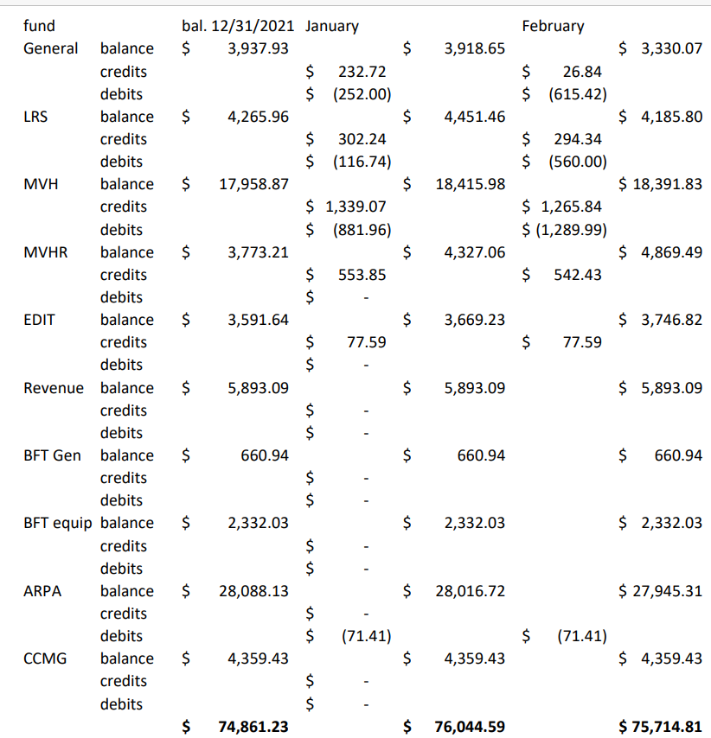
Respectfully submitted, Approved,

Ruth Strickland David Willis

